Lab 1: Study of Network Devices and Network Cabling

1.1) Simulating a Network using Cisco Packet Tracer

Objective:

To construct Network Topologies

To configure network devices

Theory
Cisco Packet Tracer is a network simulation and visualization software developed by Cisco Systems. It allows students and network engineers to design, configure, simulate, and troubleshoot computer networks in a virtual environment without requiring physical hardware. The software provides a wide range of networking devices such as routers, switches, hubs, servers, wireless devices, and end devices, enabling users to create different network topologies and study network behavior.
Packet Tracer is widely used for learning networking concepts, testing network designs, and practicing device configuration using Cisco IOS commands.

Key Components
- Router
A router is a Layer 3 networking device that connects different networks and forwards data packets based on IP addresses. It determines the best path for data transmission between networks.
Functions:
- Connects multiple networks
- Performs routing
- Enables communication between different subnets
- Provides Internet connectivity
2. Switch
A switch is a Layer 2 device used to connect devices within the same Local Area Network (LAN). It forwards data using MAC addresses.

Functions:
- Connects computers in a LAN
- Reduces network collisions
- Improves network efficiency
- Supports VLAN implementation
3. Hub
A hub is a basic networking device that broadcasts incoming data to all connected devices without filtering.
Functions:
- Connects multiple devices
- Operates at the Physical Layer
- Broadcasts data to all ports
4. End Devices
End devices are the source or destination of network communication.
Examples:
- PCs
- Laptops
- Smartphones
- Printers
- Servers
5. Server
A server provides services and resources to client devices over a network.
Services Provided:
- Web hosting
- Email services
- File sharing
- DNS and DHCP services
6. Wireless Access Point (AP)
An access point enables wireless devices to connect to a wired network through Wi-Fi communication.
7. Modem
A modem converts digital signals into analog signals and vice versa for communication over Internet service provider networks.
8. Telnet
Telnet is a remote access protocol used to manage networking devices over a network. Before Telnet works:
- Router interface must have an IP address.
- VTY lines must be configured.
- Password must be set
7. Command Line Interface (CLI)
The CLI is a text-based interface used to configure and manage network using commands. The CLI of router in Cisco Packet Tracer operates in two different modes:
- User EXEC mode
Prompt:
𝑅𝑜𝑢𝑡𝑒𝑟 ≫
Features:
- Limited monitoring commands
- Cannot change configuration
- Privileged EXEC mode
Prompt:
𝑅𝑜𝑢𝑡𝑒𝑟#
Features:
- Advanced monitoring commands
- Access to configuration mode
9) Interface Configuration
Interface configuration is the process of setting up a router’s network interface so it can communicate with other devices in a network.

Network Cables and Wiring
Different types of cables are used to establish connections between networking devices.
1. Copper Straight-Through Cable
Used to connect unlike devices.
Examples:
- PC to Switch
- Switch to Router
- Switch to Server
2. Copper Cross-Over Cable
Used to connect similar devices.
Examples:
- Switch to Switch
- Router to Router
- PC to PC
3. Fiber Optic Cable
Used for high-speed communication over long distances with minimal signal loss.
4. Console Cable
Used to configure routers and switches through a console connection.

Introduction to Network Topologies
A network topology refers to the physical or logical arrangement of devices and communication links within a network. The topology determines how devices communicate and exchange data.
1. Bus Topology
All devices are connected to a single backbone cable.
Advantages:
- Simple installation
- Low cost
Disadvantages:
- Backbone failure affects the entire network
- Difficult troubleshooting
2. Star Topology
All devices are connected to a central switch or hub.
Advantages:
- Easy management
- Easy fault isolation
- Most used topology
Disadvantages: Failure of central device affects communication
3. Ring Topology
Each device is connected to two neighboring devices, forming a circular structure.
Advantages: Predictable data transmission
Disadvantages: Failure of one node can disrupt the network
4. Mesh Topology
Every device is connected to every other device.
Advantages:
- High reliability
- Multiple communication paths
Disadvantages: Expensive and complex
5. Hybrid Topology
A combination of two or more topologies.
Advantages:
- Flexible
- Suitable for large organizations
Disadvantages: Higher implementation cost

Components Required:
  - Switch
  - Router
  - PC
  - Console Wire
  - Copper Wire
    - Straight-through
    - Cross-over

Procedure:
1) Star Topology
Steps:
- Open Cisco Packet Tracer.
- From Network Devices, select Switch and drag a switch to the logical workspace.
- From End Devices, drag 3–4 PCs to the logical workspace.
- Select Connections.
- Select Copper Straight-Through Cable and connect each PC to the switch.
- Label each PC with its own logical IP address (e.g., 192.168.1.1, 192.168.1.2, 192.168.1.3, 192.168.1.4).
- Verify connectivity by sending ping packets between the PCs.
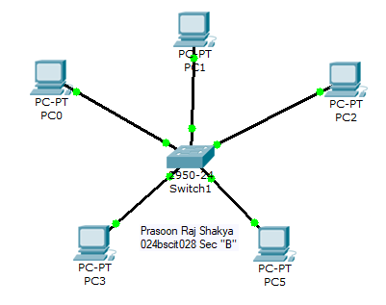

2) Bus Topology
Steps:
- Open Cisco Packet Tracer.
- From Network Devices, select Hub and drag a hub to the logical workspace.
- From End Devices, drag 3–4 PCs to the logical workspace.
- Select Connections.
- Select Copper Straight-Through Cable and connect each PC to the hub.
- Label each PC with its own logical IP address (e.g., 192.168.1.1, 192.168.1.2, 192.168.1.3, 192.168.1.4).
- Verify connectivity by sending ping packets between the PCs.
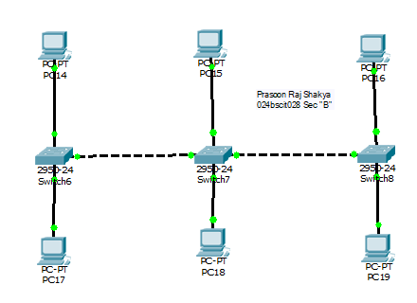

3) Ring Topology
Steps:
- Open Cisco Packet Tracer.
- From Network Devices, drag 4 switches to the logical workspace.
- Arrange the switches in a circular (ring) structure.
- Select Connections.
- Select Copper Cross-Over Cable and connect each switch to the next switch, then connect the last switch back to the first switch.
- From End Devices, drag 4 PCs to the logical workspace.
- Connect each PC to a switch using Copper Straight-Through Cable.
- Label each PC with its own logical IP address (e.g., 192.168.1.1, 192.168.1.2, 192.168.1.3, 192.168.1.4).
- Verify connectivity by sending ping packets between the PCs.
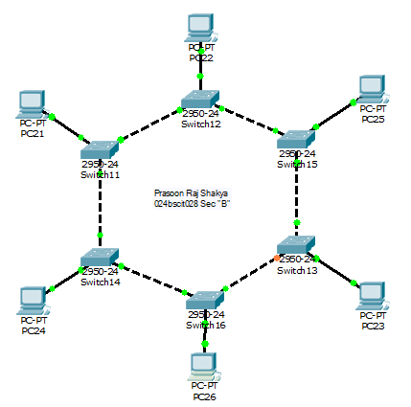
4) Mesh Topology
Steps:
- Open Cisco Packet Tracer.
- From Network Devices, drag 4 switches (or routers) to the logical workspace.
- Arrange the devices in a square pattern.
- Select Connections.
- Select Copper Cross-Over Cable and connect every device with every other device.
- From End Devices, drag 4 PCs to the logical workspace.
- Connect each PC to a switch using Copper Straight-Through Cable.
- Label each PC with its own logical IP address (e.g., 192.168.1.1, 192.168.1.2, 192.168.1.3, 192.168.1.4).
- Verify connectivity by sending ping packets between the PCs.

5) Hybrid Topology
Steps:
- Open Cisco Packet Tracer.
- Create a Star Topology using one switch and multiple PCs.
- Create a Bus Topology or Ring Topology in the same workspace.
- Connect the two topologies using a switch or router.
- Select appropriate cables from Connections.
- Connect all devices according to the chosen hybrid design.
- Label each PC with its own logical IP address (e.g., 192.168.1.1, 192.168.1.2, 192.168.1.3, 192.168.1.4).
- Configure routing if different networks are used.
- Verify connectivity by sending ping packets between the PCs.
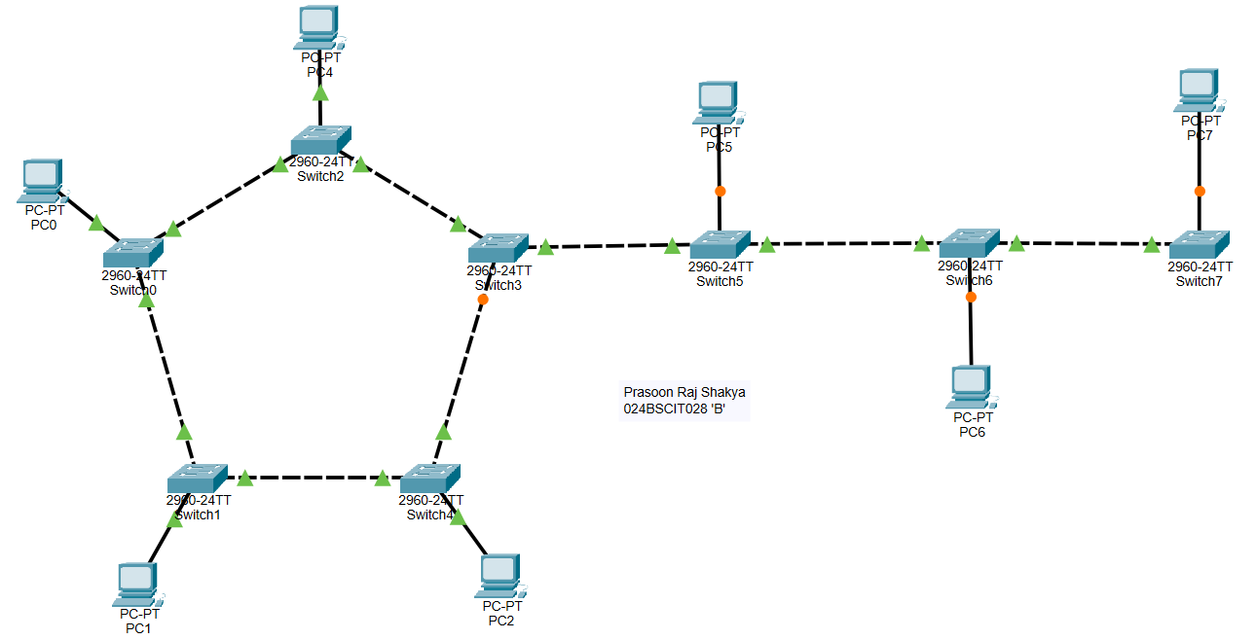

6) Network Device Configuration
6.1) Network Configuration
Steps:
- Place a switch and two end devices in the workspace
- Establish the following connections:
  - End devices to the Switch
  - Switch to the Router
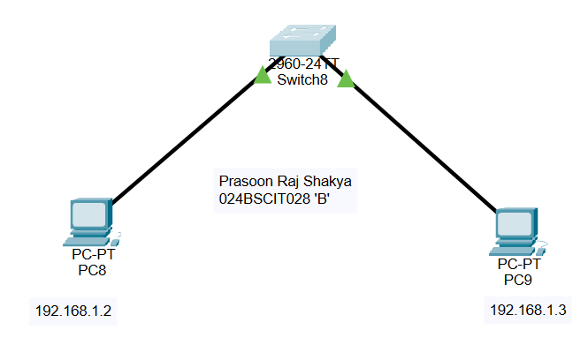
- Assign IP addresses to all PCs within the same network range.

IP Configuration
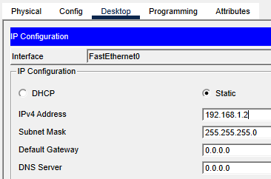
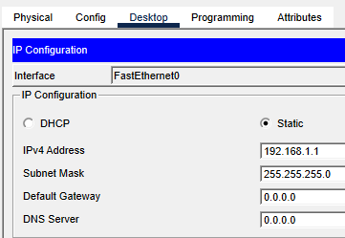

6.2) Verifying Network Connectivity
- Open the Command Prompt on any PC.
- Execute the following command: ping 192.168.1.2
- If reply messages are received successfully, network communication has been established correctly.
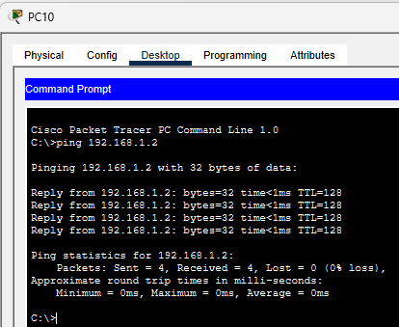

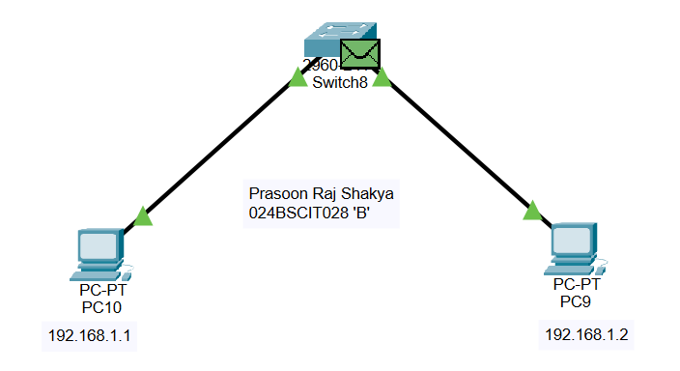
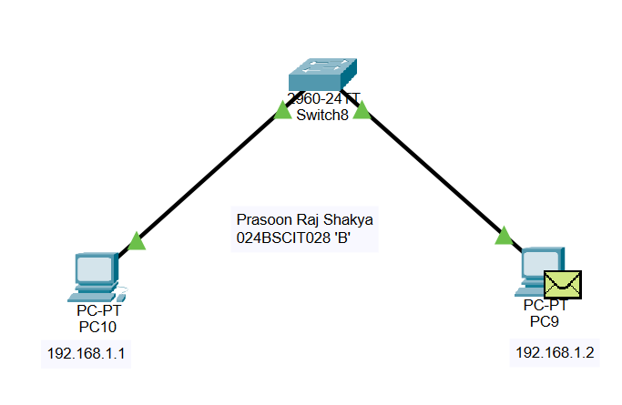
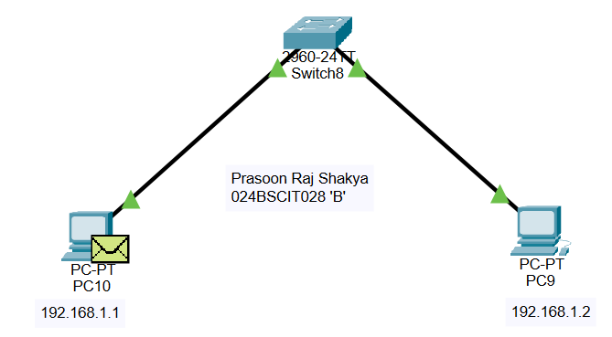
Output

6.3) Connecting the router Through Console
Steps:
- Open Cisco Packet Tracer
- Place one router and one laptop in the workspace
- Select the console cable
- Connect:
  - Laptop RS-232 port
  - Router Console port
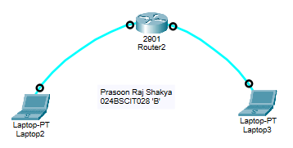
- Open laptop
- Go to: Desktop → Terminal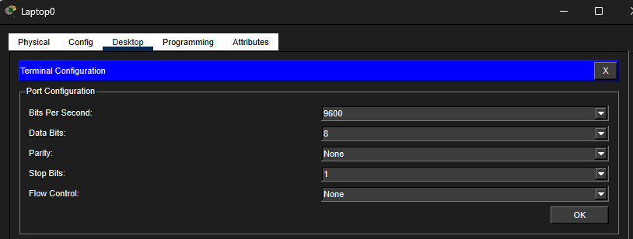
- Press OK to open the terminal

6.4) Configuring Hostname and Passwords
Steps:
- Enter global configuration mode:
Router#configure terminal
- Change hostname:
Router(config)#hostname Prasoon_028
- Configure enable password:
Prasoon_028(config)#enable password test
- Configure encrypted secret password:
Prasoon_028(config)#enable secret test1
- Exit configuration mode:
Prasoon_028(config)#^Z
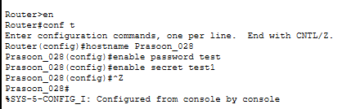

6.5) Configuring Console Password
Steps:
- Enter configuration mode:
Prasoon_028#conf t
- Configure console line:
Prasoon_028(config)#line console 0
- Set password:
Prasoon_028(config-line)#password console
- Enable login
Prasoon_028(config-line)#login
- Exit
Prasoon_028(config-line)#end
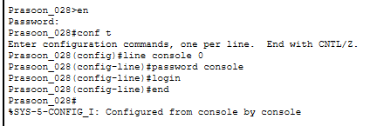

6.6) Configuring AUX Password
Steps:
- Connect another laptop to the AUX port.
- Enable:
𝑒𝑛
- Enter configuration mode:
𝑐𝑜𝑛𝑓 𝑡
- Configure AUX line
𝑙𝑖𝑛𝑒 𝑎𝑢𝑥 0
- Set password:
𝑝𝑎𝑠𝑠𝑤𝑜𝑟𝑑 𝑎𝑢𝑥
- Enable login
𝑙𝑜𝑔𝑖𝑛
- Exit
𝑒𝑛𝑑
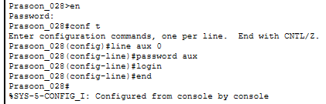

7) Telnet
7.1) Configuring Telnet
- Configure VTY lines:
Prasoon_028#conf t
Enter configuration commands, one per line. End with CNTL/Z.
Prasoon_028(config)#line vty 0 4
Prasoon_028(config-line)#password vty
Prasoon_028(config-line)#login
Prasoon_028(config-line)#end
- Save configuration
Prasoon_028#wr
Building configuration...
[OK]
7.2) Testing Telnet
- Open PC command prompt
- Enter:
telnet 192.168.1.1
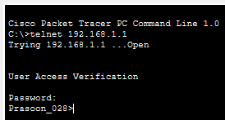
- Enter password: vty
- Remote access to the router is established successfully.

Conclusion
This experiment provided practical exposure to various network topologies and networking devices using Cisco Packet Tracer. Different topologies such as Star, Bus, Ring, Mesh, and Hybrid were successfully constructed and analyzed. The lab helped in understanding the roles of essential network components including routers, switches, hubs, end devices, and different types of network cables. It also demonstrated how network structure affects communication, reliability, scalability, and overall network performance.
Furthermore, the experiment introduced basic network device configuration techniques such as assigning IP addresses, verifying connectivity using ping commands, configuring router hostnames and passwords, establishing console connections, and enabling remote access through Telnet. Through these activities, a clear understanding of network design, device configuration, and troubleshooting was developed, providing a strong foundation for advanced networking concepts and practical network administration.

